UMS Company Background and Philosophy

Utility Mapping Services, Inc. (UMS) is a private engineering / geophysics firm that specializes in subsurface utility engineering (SUE) for civil design projects. The firm’s principals, Philip J. Meis, P.E., and Nicholas Josten, are seasoned professionals, each with 20 years experience in civil engineering and geophysical investigations. UMS approaches SUE as a rigorous engineering discipline with the intent of focusing resources and effort to specifically facilitate the objectives of the designer. We understand the design process, schedule, and budget constraints for transportation projects and customize the scope of work for each SUE campaign to be optimally cost effective while providing invaluable cost saving data. Our data management techniques are the most sophisticated in the SUE profession. Using relational databases we enable the designer to leverage the full value from SUE investigation by providing exacting data queries and formatted reports. UMS professionals will manage the SUE data for the designer and as needed, provide recommendations for resolving utility conflicts, coordinate the resolution process, and track the progress of the relocates. Our goal is to give the designer relief from the headaches and costs (e.g., construction downtime, utility damage, and emergency relocates) due to buried surprises. We take responsibility for providing accurate utility information by placing our P.E. seal on submittals. UMS principals have been providing formal SUE services as defined by ASCE standards and FHWA guidelines since 1996.

UMS SUE Capabilities
UMS provides SUE services for local public and private entities, state transportation departments, the U.S. Department of Energy, and airports throughout the country. Our SUE program is flexible and efficient, and dedicated to accurately mapping buried and aboveground utilities for design and construction use. Our SUE team is thoroughly familiar with transportation design procedures and our engineers typically participate in progress meetings from the preliminary through final design stages.

The UMS team provides the following:
- Licensed professional engineers with transportation design experience and specializing in subsurface utility engineering, including complete utility coordination services.
- Professional geophysicists trained in the theory, use, limitations, and pitfalls of electromagnetic (EM) induction sensors, magnetic gradiometers, ground penetrating radar (GPR), and acoustic detection methods.
- SUE field technicians trained in records research, documentation, and field investigative procedures.
- Global Positioning System (GPS), MicroStation Computer Aided Design (CAD), relational database and Geographic Information System (GIS) specialists.
- Vacuum excavation methods to safely expose buried utilities at critical locations.

UMS provides MicroStation digital utility reference files prepared in accordance with DOT CAD standards.

The goal of UMS’s SUE program is to provide designers with utility plans, survey coordinate data, and utility specifications necessary to facilitate designs, protect existing utilities, and eliminate buried surprises.

Why do SUE?
- Avoid expensive damage to increasingly numerous and complex buried utilities proliferated by telecommunications deregulation and the fiber optics boom.
- Avoid contractor downtime, claims, and legal fees due to utility conflicts during construction.
- Improve construction productivity.
- SUE has been adopted as a “Best Practice” by AASHTO, AGC, APWA, FHWA, and many state, county, and city transportation departments.

Immediate Benefits From SUE
- Engineer can make/modify designs to avoid unnecessary utility relocates and provide for safety buffer between construction and sensitive utilities.
- Utility relocation process can be initiated early to avoid delays in the project schedule.
- Contractors provide tighter bids for construction.
- Worker safety enhanced by having all parties, including engineers, construction managers, contractors, utility agents, and health and safety staff aware of precise locations and types of all utilities.
- One entity takes responsibility for finding and reporting all utility data—sealed by a registered P.E.

Project Approach
UMS has developed their SUE services approach to ensure consistent, high-quality products delivered in a timely and cost effective manner. Our SUE program focuses on obtaining and utilizing SUE data acquired early in the design process for the development of design and construction plans. We approach each project from a practical perspective by communicating frequently and closely with engineers to fully understand design objectives.

UMS typically performs SUE operations in two phases. Phase I consists of designating services, using standard engineering and drafting practices to establish and record the presence and horizontal location of subsurface utilities using geophysical detection methods such as EM induction and GPR.

Phase II involves locating (test hole) services, whereby traffic control, vacuum excavation, surveying, drafting, and engineering practices are applied to establish accurate horizontal and vertical positioning of subsurface utilities, and produce a written log of each test hole. UMS SUE engineers will identify the location of these vacuum excavations after completion of Phase I investigations to meet specific needs of road designers. With careful planning and coordination the Phase II investigations can be conducted rapidly and efficiently to minimize SUE project costs. A Health and Safety Plan is prepared and approved prior to any field work.

The Phase I and Phase II activities allow the assignment of “quality levels” to the mapped underground utilities. The following four quality levels are used to identify the degree of accuracy to which the utilities are mapped:

- Level D – Most basic, information comes solely from existing utility records. Used for planning.
- Level C – Most common, involves surveying visible surface features and correlating them with quality Level D information. Useful on rural projects where utilities are not likely to be present.
- Level B – Involves designating and is the first level where SUE is used. Incorporates geophysical techniques to obtain buried utility data. Sufficient for laying out storm drain.
- Level A – Highest accuracy, involves utility locating. Use of non-destructive vacuum excavations.

UMS's Phase I responsibilities:
- Meet with designers to develop a project specific scope of work for Phase I and II SUE operations. Determine equipment, personnel, and supplies needed to perform designating services.
- Provide equipment, personnel, survey, traffic control and supplies required for standard designating services.
- Conduct records research, (utilizing ONE CALL, Blue Stakes, etc., for reconnaissance purposes; obtaining all utility/public works records, maps); interview utility companies for additional information (sizes, age, types, future plans); investigate site conditions and identify applicable project limits.
- Obtain necessary permits to work in existing streets, roads and/or on adjacent rights-of-way, including landowner permission.
- Designate the existing underground utilities including their major lateral and any overhead utilities that are within the project limits. UMS uses the various geophysical instruments in succession during utility locating surveys. Using a combination of instruments is important because each has strengths and limitations, and different types of utilities will respond more readily to different instruments.
- Prepare drawings showing all information collected in a plan format adhering to requirements and CADD standards set forth by the client, and compare with information provided from base survey; upload information into a relational database for subsequent query and formatted reports.
- Review and correct plan sheets against records, field sketches, and field notes.
- Carry out Quality Control/Quality Assurance reviews and seal appropriate work product by a staff Professional Engineer.
- When performing fieldwork on or near public streets, UMS will provide traffic control or other necessary devices, in accordance with the Manual on Uniform Traffic Control Devices (newest edition).

UMS's Phase II responsibilities:
  - Provide standard equipment, personnel, traffic control, survey and supplies required to perform normal locating services.
- Obtain necessary permits to work in existing streets, roads and/or on adjacent rights-of-way, including landowner permission.
- Contact the utility companies and one-call utility locate services 48 hours in advance to coordinate consultant activities.
- Perform geophysical sweep for the targeted underground utility.
- Excavate test holes to expose the utility and measure to both top and bottom in such a manner that ensures the safety of the excavation and the integrity of the utility.
- Survey and record the following information:
  - Horizontal and vertical location of the top utility.
  - Reasonable estimate or, when possible, measurement of a) outside diameter of utility and configuration of non-encased, multi-conduit systems, and b) bottom elevation of utility (a note will be made if bottom of utility appears irregular)
  - Utility composition and condition, when reasonably ascertainable
  - Elevation of existing grade over utility at a test hole.
  - Paving thickness and type, where applicable
  - General soil type and site conditions
- Provide permanent restoration of the pavement within limits of the original cut, including backfill and compaction methods acceptable to the client. When test holes are excavated in areas other than pavement, these disturbed areas shall be restored as nearly as reasonably possible to the condition that existed prior to excavation.
- Evaluate and compare test-hole information with utility records and identify conflicts.
- Draft all information collected in a plan format
- Test hole data will be tabulated for inclusion on the drawings and a test hole data sheet for each excavation will be provided; update utility database with QL A data.
- Carry out Quality Control/Quality Assurance reviews and seal appropriate work product by a staff Professional Engineer.

UMS uses software packages such as Survey SelectCAD© to aid in drawing SUE data in the appropriate fonts, line styles, and levels, in accordance with stipulated CADD standards. Our CADD operators only need to perform fundamental edits to complete SUE drawing files that are then referenced into design drawings for engineering development.
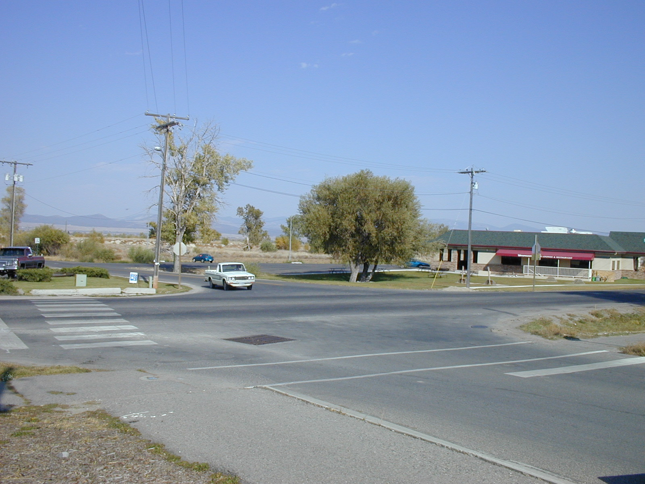
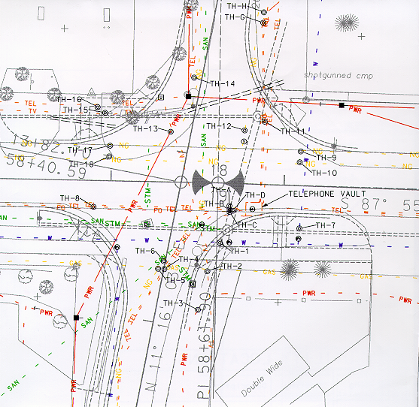

Quality Control/Quality Assurance
Field technicians involved with the SUE investigation are kept involved throughout the entire project to assure utility features found are picked up during the land survey and properly documented and presented on the CADD drawing submittals. Final drawings are checked against available utility drawings and field notes. As deemed necessary, subsequent project site visits are made to check SUE plans with utility features. Utility discrepancies, such as a deviance from as-built records, are noted and included with the submittal along with recommendations. Final plans are sealed by a licensed professional civil engineer to certify that the formal SUE process has been performed.

UMS Principals

Philip J. Meis, P.E. is a registered professional engineer (MT, ID, UT, SD, TX) and has been managing and directing subsurface utility engineering services since 1996. Mr. Meis received a B.S. in general engineering from Iowa State University (1983) and an M.S. in geophysical engineering from the Colorado School of Mines (1986). From 1986-1990 he served as a commissioned officer in the National Oceanic and Atmospheric Administration (NOAA) Corps assigned to the National Geodetic Survey (NGS) division performing geodetic and geophysical survey operations. From 1990-1995 he performed civil engineering, geophysics, and relational database development largely for mining and environmental reclamation projects. From 1995-present he has managed civil engineering operations for transportation projects with design fees exceeding $3M. Since 1996 he has been directing SUE operations throughout the country, including the $1B New I-70 Mississippi River Bridge design-build project in St. Louis, and SUE contracts for transportation departments in Illinois, Missouri, Texas, Utah, Idaho, Montana, and Washington. Mr. Meis has been pioneering data management practices for utilities in public right-of-way and is collaborating with the Texas Transportation Institute to promote on-line utility permit processing. He has spoken regularly at the National Utility Educational Conferences, numerous state DOT conferences, and has published papers advocating the use of SUE and new data acquisition and data management techniques. Cell Phone: 406.431.3617

Nicholas E. Josten has operated as an independent geophysical consultant since 1997. After earning a B.S. in geophysics from Stanford University (1981) and an M.S. in geophysics from Colorado School of Mines (1985), Mr. Josten worked 12 years as a professional geophysicist for Chevron Corporation and the Idaho National Engineering Laboratory. His professional experience includes a mixture of applied research, field geophysics and geophysical data analysis with a particular emphasis on magnetic, electromagnetic and nuclear measurement systems. Mr. Josten was among the early developers of modern shallow, high resolution engineering geophysics and has filed three patent applications, received one patent award, and published numerous papers on the topic of innovative high resolution data acquisition systems and their applications. Phone: 208.528.6152

Key UMS Staff

Jon J. Maxwell, E.I., Project Engineer has five years experience performing and managing a wide variety of subsurface utility engineering projects in Montana, Utah, Idaho and Washington. His expertise includes project scoping, scheduling, field operations, GPS and conventional survey, data reduction, CADD plan development, budgeting, and report submittals. Mr. Maxwell meets with designers during preliminary engineering stages to discuss project specific design objectives and utility issues. Cell Phone: 406.431.3615

Richard P. Clarke, Project SUE Specialist has five years experience performing records research and SUE field investigations in Montana, Utah, Idaho, Washington, Texas, Nevada, and Illinois. He has witnessed a wide array of inconceivable buried utility scenarios and has a proven record for making essential keen observations to steadfastly sort out discrepancies in records, field findings, and personal accounts reported by utility engineers and maintenance personnel. He is an expert operator of geophysical field equipment used for SUE investigations. Cell Phone: 406.431.7903

Chris McMahon, Project SUE Specialist has five years experience engineering and installing fiber optic network installations across the nation. Mr. McMahon is completely fluent in the operation, capabilities and limitations of electromagnetic inductive sensors produced by firms such as Radio Detection and MetroTech, His knowledge is invaluable for ensuring that buried utilities have been correctly and accurately detected and delineated. Mr. McMahon isolates segments where inductive coupling is insufficient so that appropriate alternative investigative efforts are applied and/or utility plans are properly annotated. His skills play a direct role in mitigating the need for expensive vacuum excavation test holes.

Craig Hyslop, Staff Geophysicist has two years experience with high resolution geophysical investigations, survey, CADD, and report preparation. Mr. Hyslop is a recent graduate from the Montana Tech. Geophysical Engineering program and understands the applied theory used to located buried utilities, as well as the pitfalls that can occur.

Blake Peterson, CADD Specialist has five years experience developing MicroStation CADD utility reference files per UDOT standards for SUE investigations. Mr. Peterson is proficient with Survey SelectCAD, a third party software used to import survey data and draw features on plans using proper UDOT CAD standards and levels. Mr. Peterson completes final edits, assigning appropriate quality levels and entering field notes for utilities mapped during the SUE Phase I (Designating) and Phase II (Locating) operations. Mr. Peterson also performs field operations as needed and is familiar with all procedures necessary to perform an SUE investigation.

UMS Principal Experience – Mr. Meis
Project manager for three consecutive two-year term contracts to supply subsurface utility engineering (SUE) services for the Montana Department of Transportation. Project tasks include: records research; traffic control; detection, survey, and detailed mapping of all utilities; conflict identification, and report writing and development of CADD plans in MDT MicroStation format. Some projects performed under rapid schedule. Over 80 projects and $1M of services performed successfully for MDT. (Montana Department of Transportation, Helena, MT 1996 – 2002)

Project manager for a $1M two-year term contract to provide subsurface utility engineering (SUE) services for the Texas Department of Transportation (TxDOT). Project tasks include: records research; traffic control; detection, survey, and detailed mapping of all utilities; and report writing and development of CADD plans in TxDOT MicroStation format. Project work may also include utility data management activities to facilitate utility coordination activity. (Texas Department of Transportation, Helena, MT 2002 - ongoing)

Project director for a $350,000 contract to provide subsurface utility engineering (SUE) services for the Illinois Department of Transportation (IDOT) New Mississippi River Bridge design – build specifically involving the Project 066N, Relocated Route 3 North and Project 067, the I-55/I64/I70 Tri-Level Interchange. Work includes utility coordination work for the above two roadway alignments plus seven miles of new railroad alignment. Work being performed under a fast-track schedule. Project tasks include: records research; traffic control; detection, survey, and detailed mapping of all utilities; utility conflict identification and resolution recommendations; and report writing and development of CADD plans in IDOT MicroStation format. Work also includes development of a GIS relational database and utility data management activities to facilitate utility coordination activities. (HNTB Architects Engineers Planners, St. Louis, Missouri 2001 - ongoing)

Project director for a two-year service agreement to provide subsurface utility engineering (SUE) services for the Utah Department of Transportation (UDOT). Project tasks include: records research; traffic control; detection, survey, and detailed mapping of all utilities; and report writing and development of CADD plans in UDOT MicroStation format. Projects have included complex urban projects in downtown Salt Lake City including State Street ($120K), 106th South ($80K), Redwood Road ($150K). (Utah Department of Transportation, Salt Lake City, Utah 2000 - 2002)

Project director for $500,000 two-year term contract to provide subsurface utility engineering (SUE) services for the Idaho Transportation Department (ITD). Project tasks include: records research; traffic control; detection, survey, and detailed mapping of all utilities; and report writing and development of CADD plans in ITD MicroStation format. First firm to provide SUE services for ITD (Oak – Cedar Street, Pocatello, ID, Spring 2002, $38K). Project work has included significant ground radar investigations. (Idaho Transportation Department, Boise, Idaho 2001 - ongoing)

Project manager for $20,000 contract to provide SUE services for Lake Tahoe Hyatt Regency expansion design project. Project included significant ground radar investigation. (Lundahl Architects, Lake Tahoe, Nevada, 2002)

UMS Principal Experience – Mr. Josten
Magnetic and EM Induction Surveys at the U.S. Naval Explosive Ordnance Live Site, Eglin Air Force Base, FL. Investigated a 9 acre section of the Eglin Air Force Base Ordnance Live Site as part of a development effort to improve a proprietary ordnance detection system. The primary focus of this effort was a comparison between high resolution magnetic data and time domain EM induction data for use in detecting small ordnance and in resolving ordnance mass. Performed analysis of the magnetic data resulting in a comprehensive target list, depth estimates, and broad ordnance classification.

Pit 9 Surface Geophysics, Idaho National Environmental and Engineering Laboratory, Idaho Falls, ID. Investigated a 0.7 acre portion of Pit 9 at the Idaho National Engineering and Environmental Laboratory Subsurface Disposal Area using a combination of vertical gradient magnetics and time domain EM induction. Magnetic data were collected using the RGS-10 data collection system, developed by Mr. Josten. Conducted data integration with historical waste disposal records and previously collected geophysics data (including seismic refraction data) and developed a GIS-type archive of data and results. Target depth, pit boundary, and well location screening analyses were performed to address project requests. Summary interpretation graphics were produced to support management reviews and decisions.

Pits 4-6-10 High Resolution Surface Geophysics, Idaho National Environmental and Engineering Laboratory, Idaho Falls, ID. Designed and conducted a high resolution landfill survey that included magnetic, EM induction and refraction seismic methods. Compiled, processed and analyzed the field data, and generated the final report. Analysis included bedrock depth interpretation, metallic waste depth estimates, conductivity and magnetization analysis, and interpretation of pit boundaries.

Utility Screening Survey, Washington Group International, Inc., Boise, ID. Performed geophysical investigation using a high resolution magnetic gradiometer to establish location of buried utilities prior to building construction. Investigation areas were immediately adjacent to metal walls, with no utilities exposed, creating a complex analysis problem.

